Human-Centered Design

In developing this prototype, we utilized the following human-centered design techniques: 1) User Stories 2) Personas 3) User Interviews 4) Rapid Prototyping using Wireframes 5) Screen design sketches 6) Usability Testing

INSPIRATION

##### The team gathered in the conference room to first get re-acquainted with the task, and then in our respective roles dive into brainstorming to develop user stories with a deep awareness of human-centeredness.

Because we determined that the best product could only be developed by knowing, empathizing with, and understanding the user, we primarily focused our time on defining our target audience, the identity and needs of the likely users, and immersing ourselves in the collective knowledge of the foster care system.

We did this by sharing with one another what we already knew from personal foster care experience and what we had begun to discover through research and interviewing potential users. We identified themes, bundled ideas, and prioritized key concepts to begin to shape our user stories.

* With that said, who IS the user and what does he/she CARE about?

IDEATION

User Interviews, Personas, and User Stories

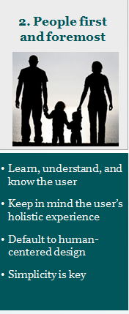The user research team put together a collection of personas they anticipated would represent our target audience and in real time made manual updates based on the live discussion with the team including our users.

In particular, one of the users has an extensive personal background with the foster care system; she was able to enlighten the group as we brainstormed ideas for the details that culminated into user stories. We continued to interview her and utilize her expertise as a resource for understanding the user throughout the entire design process.

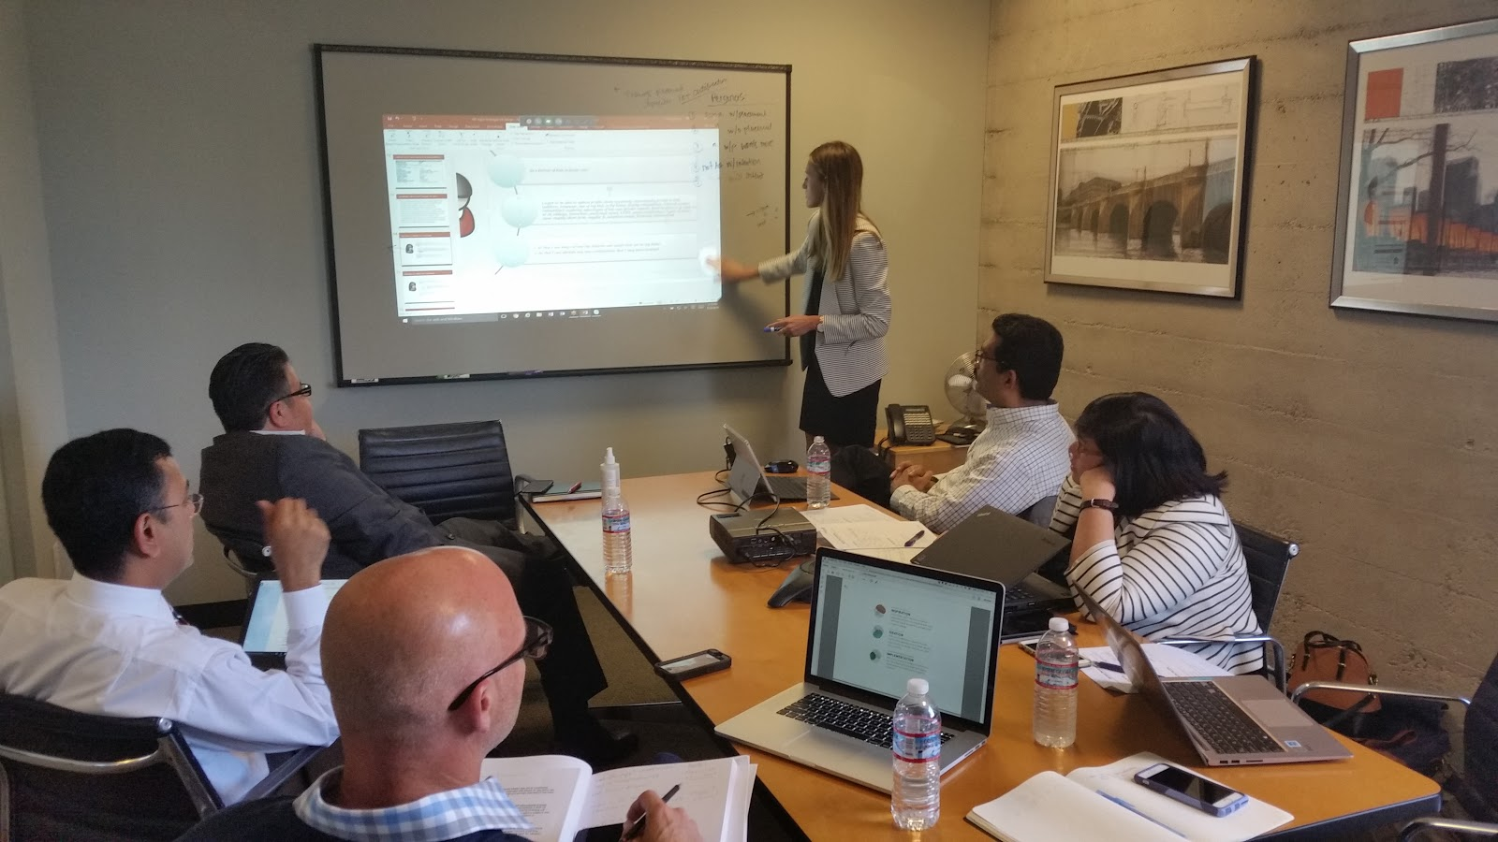

*The Cambria team discussing who are users are and developing personas*

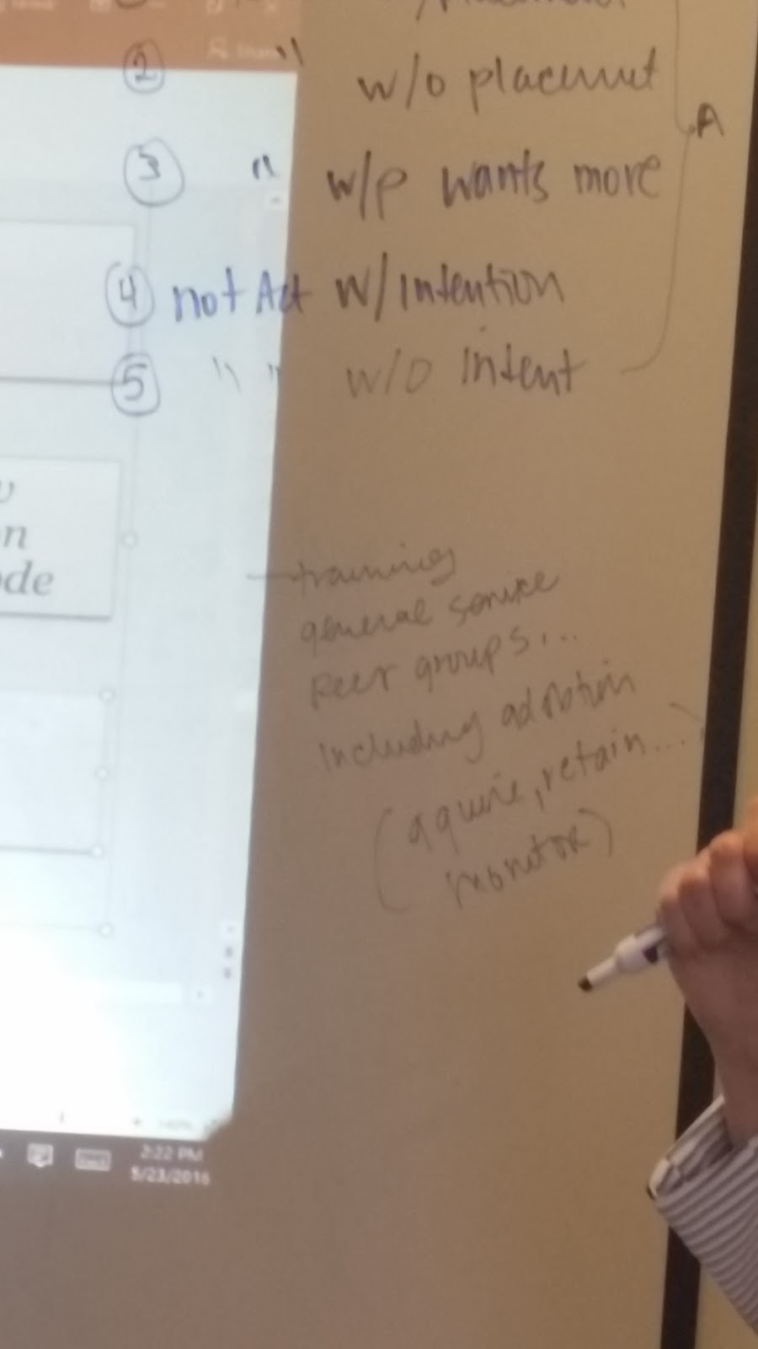

*Drawing up details about the different possible users and what their needs are in real time*

After this initial discussion and collaboration, we were off to a good start for understanding key components of who were creating for but we still had more discussing and fleshing out to do to come up with poignant yet simple user stories. Over the next 24 hours, through small group discussions and follow-up user interviews, the team iteratively defined the users we were targeting by developing the personas and then drilling down on the user stories.

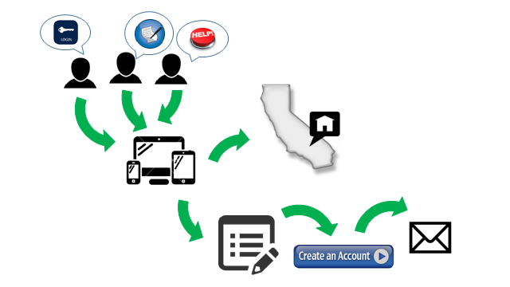

*Vision document business/user design team drafted as they talked through the user engagement model. They developed multiple iterations to shape our personas and capture user cases during the user interaction development process.*

**Assumption:** We defined the parent to be a foster parent and not a biological parent

Personas: Monica (1) and Charles (2)

(1)

Meet Monica

🡺 Licensed as a foster parent

🡺 Looking for support and training

🡺 Wants the best possible match for her family

Monica Cares Most About...

**Best Placement**

* Matching kids with the right families upfront will ensure greatest success

**24/7 Resources**

* Online mechanism to provide families with the information they need as quickly as possible
* Ability to communicate with caseworker at all hours

**Ease of Entry**

* For facilitating recruitment
* Assist her in advocating to friends and personal community about foster parenting

Monica's Story

**Personal:**

Monica grew up in a family with parents who were certified foster parents in California and therefore witnessed first hand the foster care dynamics from inside the home and on a relational level. Monica was impacted by the tough transitions the children weathered, in particular, when they were taken from the homes of their biological parents.

She also empathized with other transitional challenges they experienced such as adjusting to new schools, environments, families, and relationships. She believes that extensive support services for foster care parents are required for success especially in light of the lack that she personally witnessed.

**Professional:**

Monica has also been engaged with the child welfare system from policy to implementation for most of her career . Her roles included managing State and County level programs as an Agency Official, and running the Florida and Colorado systems as a Regional and County Administrator. Sherry oversaw investigations, QA, response teams, and direct services. She also led case workers and interacted with foster care and adoption agencies within the context of community service organizations.

(2)

Meet Charles

🡺 Experienced and licensed case worker

🡺 Prioritizes safety and well-being of the child

🡺 Wants to ensure children are receiving adequate care

Charles Cares Most About...

**Safety and Well-being**

* Assurance that the kids are well taken care of and safe
* Knowledge of child’s wellbeing during transitional period to new schools and home

**Proper Treatment**

* Children with emotional and mental health issues are receiving correct care regularly

**Support for Foster Parents**

* Provide advice and assistance to foster parents via regular communication
* Offer suggestions for training and support services available to families

Charles' Story

**Professional:**

Charles has extensive professional experience with the foster care system in various capacities throughout his career working with the public sector. Specifically, he assisted in the creation of the eligibility determination system for foster care as part of CalWIN. Charles was also an integral part of developing a prototype for an application that tracks the approval process of psychotropic medications for kids in the foster care system. This was part of California’s State System Interoperability and Integration program initiated by the Federal government.

From an advisory capacity, Charles contributed to the Court Appointed Special Advocates (CASA) organization. This particular role helped shape his priorities as a case worker of ensuring safety and promoting permanency as much as possible.

##### User Stories

1. **User Story #1**

As a foster parent, I want to be able to make changes to my profile so that it is reflective of my current family status so that my availability and type of placements is clear.

Persona: Monica

1. **User Story #2**

As a foster parent, I want to be able to search for and view children’s residential facilities in my Zip Code, so that I can locate the nearest agency for obtaining training and other support services that is either near my home or near where I work.

Persona: Monica

1. **User Story #3**

As a foster parent, I want to be able to communicate with my child’s case worker via private inbox, so that I can quickly escalate issues and/or collaboratively make informed decisions about the child(s) health and safety.

Persona: Monica

1. **User Story #4**

As a case worker, I want to be able to communicate with my child’s foster parent via private inbox, so that I can easily communicate with working foster parents to coordinate periodic visits as well as stay abreast of any changes in the needs of the child or additional supports that can be provided to the parents.

Persona: Charles

IMPLEMENTATION

Wireframes and Screen Design Sketching

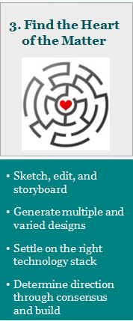Once we had a handle on the personas/target audience and the user stories we would build around, the interaction design team began to draft a series of wireframes that would respond most effectively to the users' needs.

<insert more text about developing wire frame and iterative approach here>

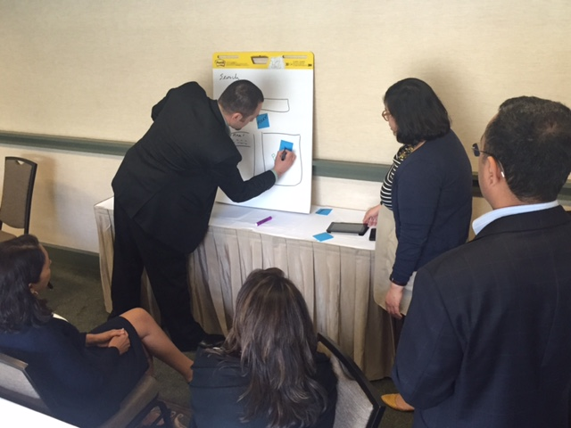

*User design session*

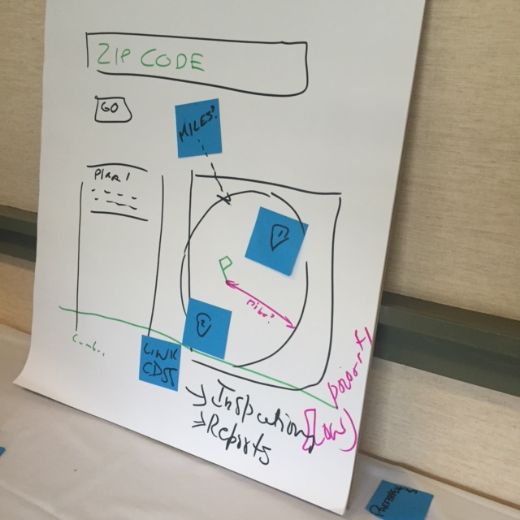

*Wireframe sketch*

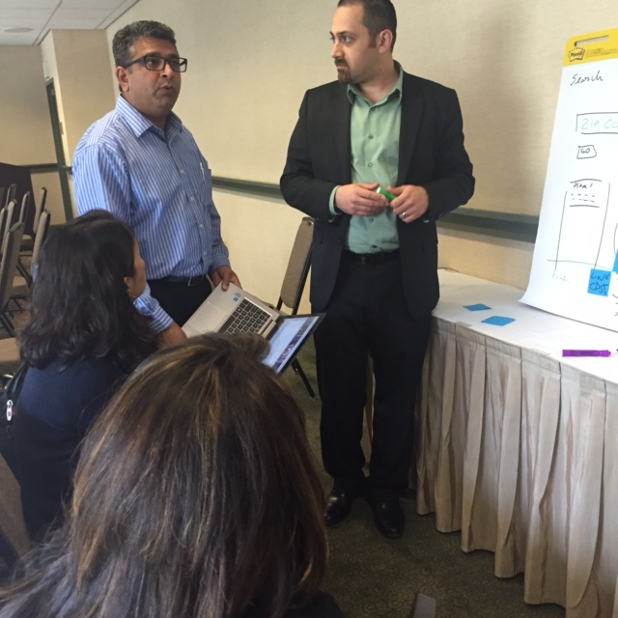

*Discussing design sketches with the users and editing*

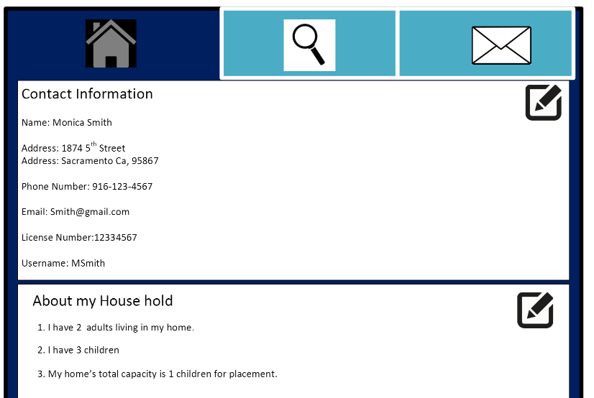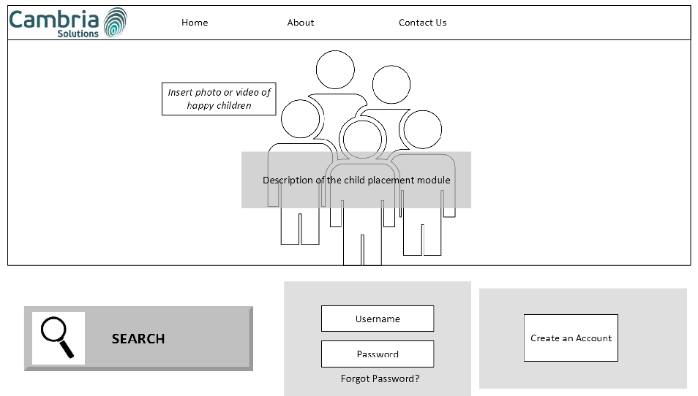

*Initial wireframes*

Visual Design and Style Guide

The user design team also worked with our visual designer to rapidly prototype through iterations of the wireframes based on what would most suit the experience of our identified users.

Our visual designer crafted the look and feel of the application, which included creating the style guide. Our creative process included defining user flow, producing content strategy, user testing throughout, designing visual wireframes, and establishing a digital art direction.

He drafted ideas through envisioning the user and how he or she might interact with the application, and then sketched screen designs that would appropriately speak to his or her expectations.

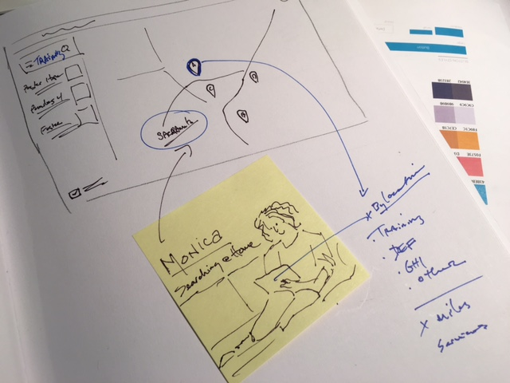

*Search screen sketch*

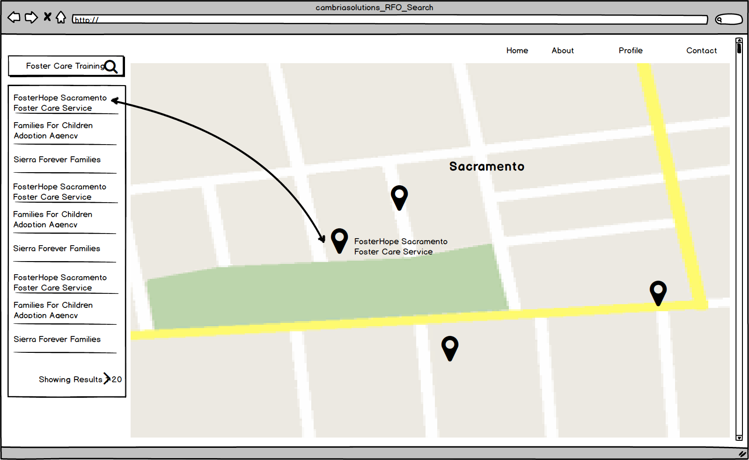

*Search screen wireframe*

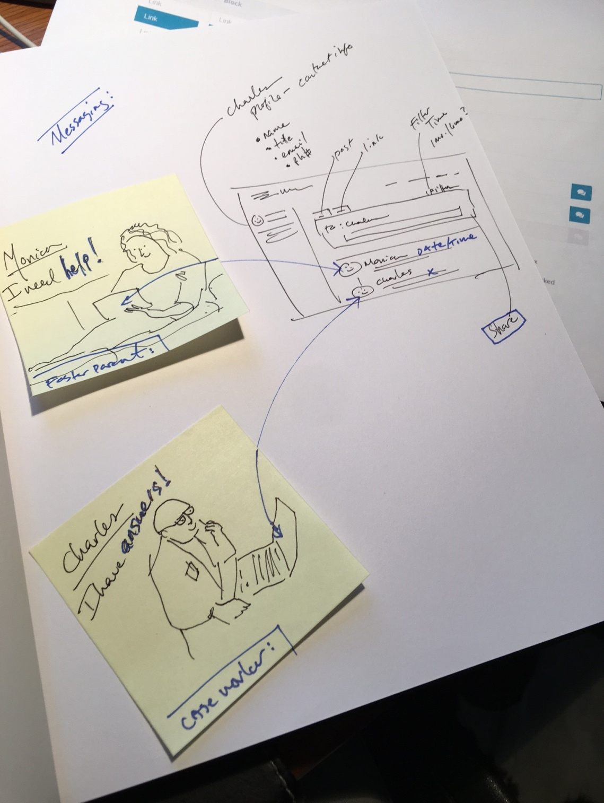

*Inbox messaging sketch*

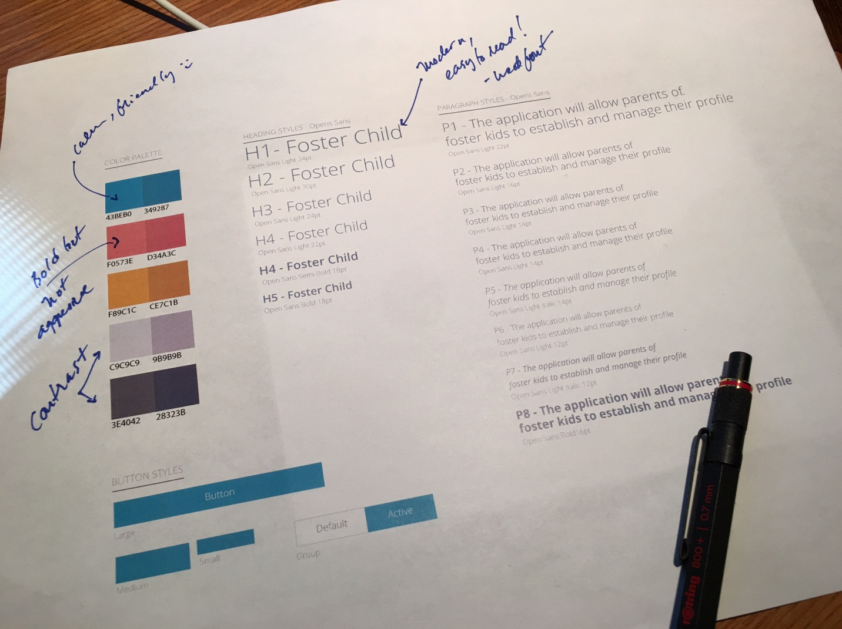The creation of the style guide was central component to the visual design process. We approached the style guide founded on an understanding of its significant impact on the way users perceive and feel about their interactive experience and the brand itself. We prioritized the use of inspirational pictures, friendly and empathetic tone, persona based branding, being intuitive and relevant, conversational nature, and presentation of the Cambria brand.

*Style guide with visual design notes*

Usability Testing

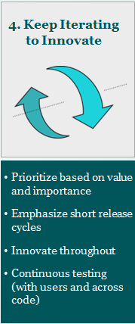

Our usability testing focused on understanding the users, their needs, and what they value. With this core perspective, we continuously integrated the users' responses and feedback to innovate and prioritize with each iteration.

Our representative users, who were located different geographical areas, became our testers and utilized a variety of devices and platforms. Based on their feedback, we noted enhancements as issues for every sprint, and used the information collected to evaluate the usability of the application and recommend improvements with each successive sprint. The users began testing in sprint 2 and continued throughout all subsequent sprints.

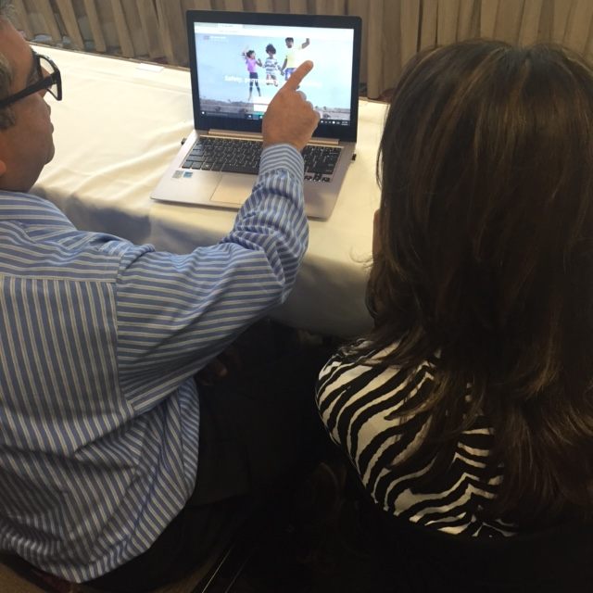

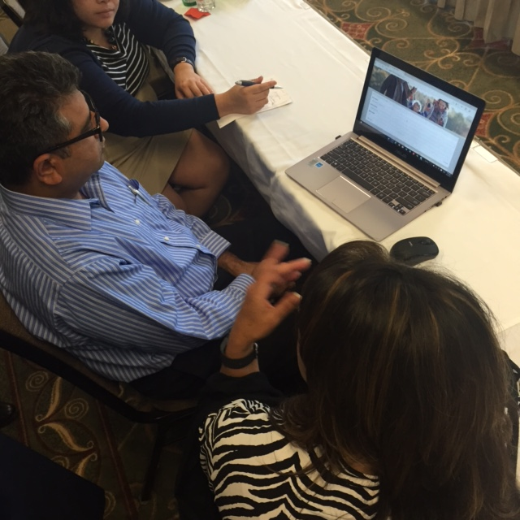

*Live usability testing*

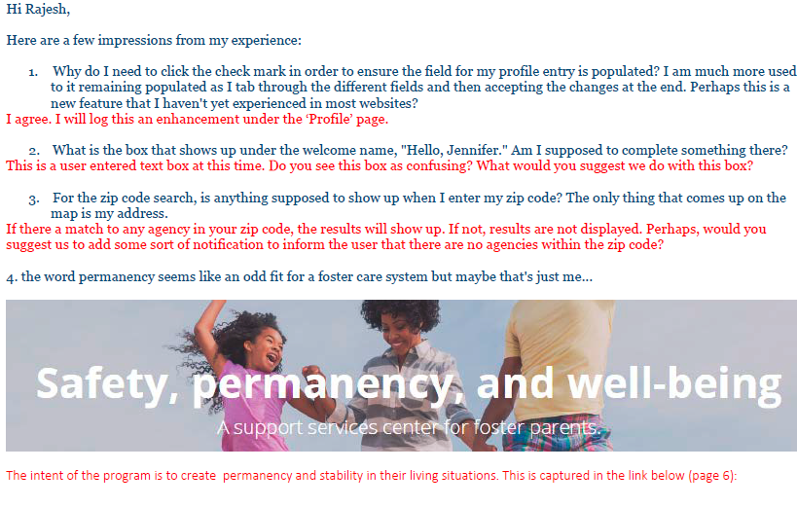

*Email feedback from one of our offsite users*